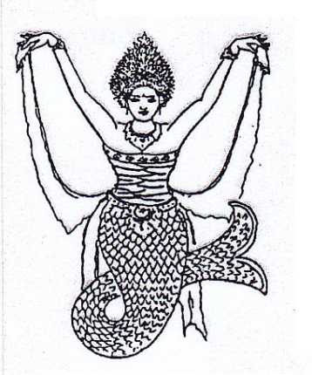 ABSENSI SISWI TARI BALI “ NYALIAN MAS “

**Pengajar : Nining. N Tahun ajaran : 2020-2021**

**Bulan : Kelas : Senin & Kamis ( Malam)**

|  |  |  |  |  |  |  |  |  |  |  |  |  |
| --- | --- | --- | --- | --- | --- | --- | --- | --- | --- | --- | --- | --- |
| **No** | **Nama** | **No.Induk** | **Tanggal** | | | | | | | | | |
|  | | | | | | | | | |
| **1.** | **Aldina Agmay Safira** | **189** |  |  |  |  |  |  |  |  |  |  |
| **2.** | **Allya Camilla Putri Yunanto** | **174** |  |  |  |  |  |  |  |  |  |  |
| **3.** | **Anindya Kinara Setyawan** | **200** |  |  |  |  |  |  |  |  |  |  |
| **4.** | **Brigita Anggun Maharani** | **185** |  |  |  |  |  |  |  |  |  |  |
| **5.** | **Fida Fauzia Nawawi** | **172** |  |  |  |  |  |  |  |  |  |  |
| **6.** | **Gladisa Maharani** | **165** |  |  |  |  |  |  |  |  |  |  |
| **7.** | **Ni Luh Wedasri Febriani** | **139** |  |  |  |  |  |  |  |  |  |  |
| **8.** | **Quaneisha N Alzena** | **207** |  |  |  |  |  |  |  |  |  |  |
| **9.** | **Rafeyfa Asyla** | **148** |  |  |  |  |  |  |  |  |  |  |
| **10.** | **Raina Athiyya Archisaputra** | **194** |  |  |  |  |  |  |  |  |  |  |
| **11.** | **Shelina Rahmah** | **141** |  |  |  |  |  |  |  |  |  |  |
| **12.** | **Yasmin Dhiya Ulhaq** | **188** |  |  |  |  |  |  |  |  |  |  |
| **13.** | **Dian** |  |  |  |  |  |  |  |  |  |  |  |
| **14.** | **Theresa** |  |  |  |  |  |  |  |  |  |  |  |
| **15.** | **Gendhis** |  |  |  |  |  |  |  |  |  |  |  |
| **16.** | **Naomi** |  |  |  |  |  |  |  |  |  |  |  |
| **17.** | **Yasmin Ayu** |  |  |  |  |  |  |  |  |  |  |  |
| **18.** |  |  |  |  |  |  |  |  |  |  |  |  |
| **19.** |  |  |  |  |  |  |  |  |  |  |  |  |
| **20.** |  |  |  |  |  |  |  |  |  |  |  |  |
|  |  |  |  |  |  |  |  |  |  |  |  |  |
|  |  |  |  |  |  |  |  |  |  |  |  |  |